Project Idea:  
Bringing Cities Back to People.

The project idea is to create train lines – railyards, railroads, electrification plots for countries/cities mentioned in a csv file with set budget.

This line should be aware of the terrain that it is about to maneuver through such as mountains, valleys, waterways, historical sites underneath. Hugging the terrain is what we want to achieve from this program. The line should not very squiggly and make passengers sick. Budget is determined on how much the line costs as well as electrification and using RTMS/ECTS systems.

This application should be universal as in it should work in multiple countries and not only in the countries in the csv (overfitting), and it should not be static as in the ruggedness and population, and tourism index should not be the same for every city and derive it form online sources

|  |  |
| --- | --- |
|  | This line does not follow terrain, it goes underground (makes passengers sick) and ignores NIMBY and coastal preservations, we don’t want this |

Reading the CSV provided in file: input, this CSV contains – example:

city_id, city_name,

LB-BEY, Beirut

LB-TRP, Tripoli

After reading the csv the algorithm fetches the city from online sources to understand population in this city and distribution of people throughout the city to know where is best to place a station.

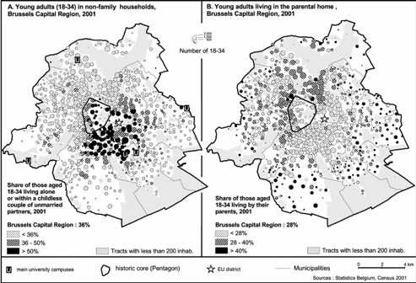 This is an example of the Brussels region as you know brussels has many Intercity and S stations throughout it and distributed rather very well throughout the city.

When researching about the city using online sources you need to understand the demand between the cities mentioned in the csv, to do that we need to use a formula that is a multi – approach.

Step 1: Regular Workers

Step 2: Students

Step 3: Tourism index

This helps better plot the stations and how many platforms a station needs – in this case more platforms = more train connections = more people using the service = less people on the street in cars = better equality for less fortunate workers.

Use online sources to determine the price per kilometer of rail and it costs for electrification, etc etc.  
Questions to ask:

* Do I electrify this region?
* Do I put a double decker train on this line?
* Do I make the line high speed? If so what are the costs for high-speed corridor between the cities mentioned
* How much does it cost for one train (the train suggested for the line)
* Finally where to place railyard.

Not many countries are super flat like the Netherlands, it is important to use an algorithm to understand the terrain, and backtracking a bunch of nodes if a rough terrain has been reached.

* Draw a line
* Try to extend from the newest point placed
* If new point encounters: water – mountain or building, what to do next?

With the last being said, map about 5 different maps and we select the best one so we can improve model.

If cities mentioned has cities in between that we can benefit form adding to the network to increase number of passengers and therefor income = better.

This makes sense, if you add an extra city then the 5 choices should be provided with a time table and train types.

When the cities and route is plitted with the rail type we select the best vehicle to use, using everything previously in the pipeline

* Riders at hour 8am = 5000 passengers (so probably a double decker once every hour or four velaro trains every 15 minutes).

With that being said 5 different html with colors.

Colours:

* Black: underground
* Blue: above ground
* Green: on ground

Future plans: visualize using a gaming software such as cities skylines type software or interactive map. Would like to see a railway and electrification with the train on the railway